Unit 5

Topic as per syllabus | As per Text Book
Implementing File-system: File-System Structure, File-System  Implementation, Directory Implementation, Allocation methods, Free-space  management. | Chapter 12 File-System Implementation  12.1 File-System Structure 543  12.2 File-System Implementation 546  12.3 Directory Implementation 552  12.4 Allocation Methods 553  12.5 Free-Space Management 561
Mass-storage structure: Disk Structure, Disk Attachment, Disk Scheduling. | Chapter 10 Mass-Storage Structure  10.1 Overview of Mass-Storage  Structure 467  10.2 Disk Structure 470  10.3 Disk Attachment 471  10.4 Disk Scheduling 472
System Protection: Goals of Protection, Principles of Protection, Domain of  Protection, Access Matrix, Implementation of Access Matrix | Chapter 14 Protection  14.1 Goals of Protection 625  14.2 Principles of Protection 626  14.3 Domain of Protection 627  14.4 Access Matrix 632  14.5 Implementation of the Access  Matrix 636

Chapter 10

Section Number | Title | Main Topics Covered
10.1 | Overview of Mass-Storage Structure | Introduction to secondary storage devices, need for mass storage, characteristics of magnetic disks and solid-state drives (SSDs), storage hierarchy, performance measures (access time, seek time, rotational latency, transfer rate), and reliability considerations.
10.2 | Disk Structure | Physical organization of disks including platters, tracks, sectors, cylinders, read/write heads, disk controller, logical block addressing (LBA), disk capacity calculation, and how data is stored and accessed on magnetic disks.
10.3 | Disk Attachment | Methods of connecting disks to computer systems, including host-attached storage (SATA, SCSI, SAS), network-attached storage (NAS), storage-area networks (SAN), communication protocols, and advantages of different storage architectures.
10.4 | Disk Scheduling | Techniques used by the operating system to determine the order of servicing disk I/O requests. Includes FCFS (First-Come First-Served), SSTF (Shortest Seek Time First), SCAN, C-SCAN, LOOK, and C-LOOK algorithms, along with performance comparison and seek-time optimization.

10.1 Overview of Mass-Storage Structure

Section Number | Title | Topics Studied
10.1.1 | Magnetic Disks | Disk structure (platters, tracks, sectors, cylinders), read/write heads, data storage and retrieval, seek time, rotational latency, transfer rate, access time, logical block addressing (LBA), HDD advantages and limitations.
10.1.2 | Solid-State Disks (SSDs) | Flash memory organization (pages and blocks), SSD architecture, read/write/erase operations, wear leveling, garbage collection, TRIM, SSD performance, SSD vs. HDD comparison.
10.1.3 | Magnetic Tapes | Sequential-access storage, tape drives and cartridges, backup and archival storage, data retrieval process, advantages (low cost, high capacity), limitations (slow access time).

10.1.1 Magnetic Disks

Magnetic Disks
Magnetic disks provide the majority of secondary storage in modern computer systems. Data is stored magnetically on rotating disk surfaces called platters.

Disk Structure
- A disk consists of one or more circular platters coated with magnetic material.
- Common platter sizes range from 1.8 to 3.5 inches.
- Each platter surface contains a read–write head that reads and writes data.
- The heads are attached to a movable disk arm.

Data Organization
- The surface of a platter is divided into concentric tracks.
- Each track is further divided into sectors.
- A collection of tracks located at the same arm position forms a cylinder.
- Modern disks contain thousands of cylinders and hundreds of sectors per track.
- Disk capacity is typically measured in gigabytes (GB) or terabytes (TB).

Disk Rotation
- A drive motor rotates the platters at high speed.
- Common rotational speeds are:
  - 5,400 RPM
  - 7,200 RPM
  - 10,000 RPM
  - 15,000 RPM

Disk Performance Parameters

1. Transfer Rate
- The rate at which data is transferred between the disk and the computer.
- Usually measured in MB/s or GB/s.

2. Positioning Time (Random Access Time)
The time required to access a particular data block.
It consists of:
a) Seek Time
- Time required to move the disk arm to the desired cylinder.
b) Rotational Latency
- Time required for the desired sector to rotate under the read–write head.
Disk Access Time = Seek Time + Rotational Latency + Transfer Time

Head Crash
- The disk head normally floats on a thin cushion of air above the disk surface.
- If the head touches the platter surface, a head crash occurs.
- A head crash can damage the magnetic coating and cause permanent data loss.
- Usually, the entire disk must be replaced.

Removable Disks
Examples of removable storage devices include:
- CDs (Compact Discs)
- DVDs
- Blu-ray Discs
- Flash Drives (USB Drives)

Disk Attachment and Controllers
A disk drive is connected to a computer through an I/O Bus.
Common bus technologies:
- ATA (Advanced Technology Attachment)
- SATA (Serial ATA)
- eSATA
- USB (Universal Serial Bus)
- Fibre Channel (FC)

Controllers

Host Controller
- Located at the computer side.
- Sends commands to the disk.

Disk Controller
- Located inside the disk drive.
- Executes commands and controls disk operations.

Disk Cache
- Disk controllers contain a built-in cache memory.
- Data transfer occurs:
  - Between disk surface and cache
  - Between cache and host controller
- Cache improves overall disk performance.

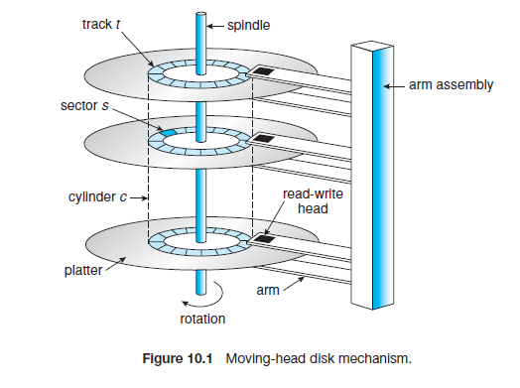
Disk Access Time = Seek Time + Rotational Latency + Transfer Time

Figure 10.1: Moving-Head Disk Mechanism
The figure shows the internal structure of a magnetic disk drive. Data is stored on rotating platters, whose surfaces are divided into tracks and sectors. A read–write head attached to a movable arm assembly moves across the disk surface to access data. The set of tracks aligned vertically on all platters forms a cylinder. During data access, the disk rotates while the arm moves the head to the required track and sector
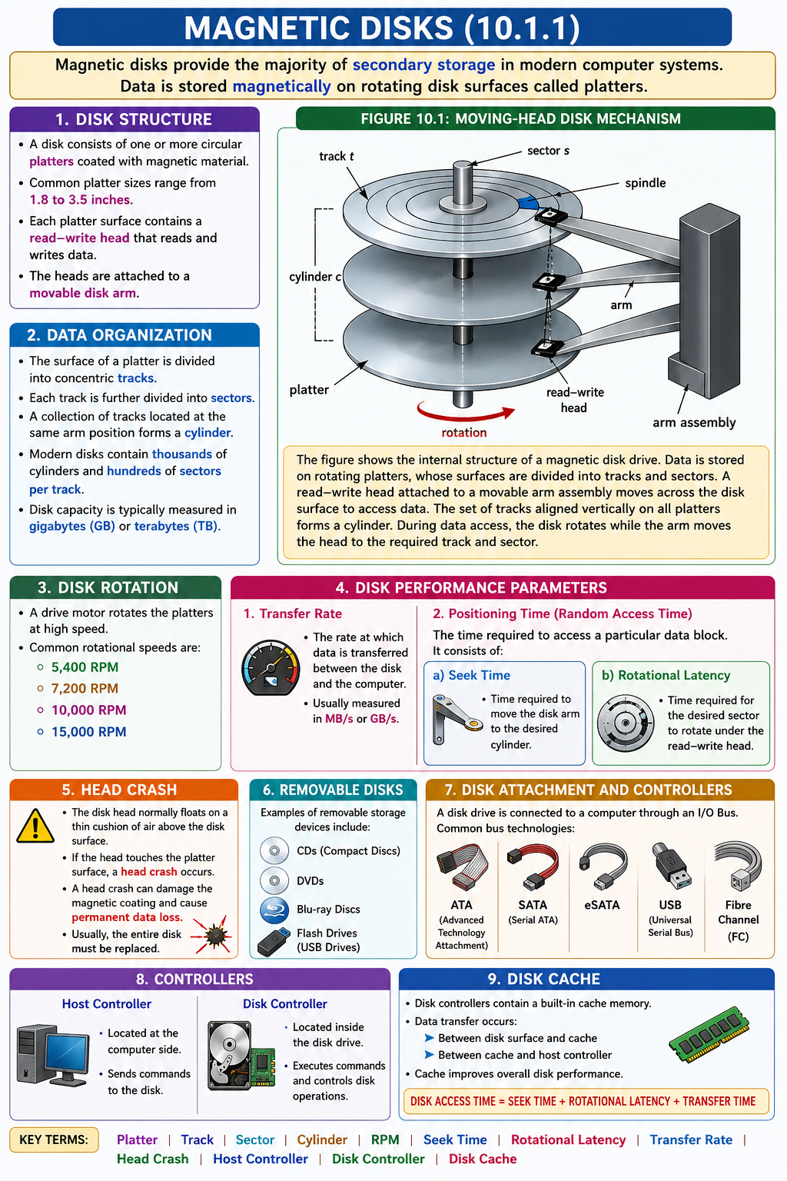

10.1.2 Solid-State Disks
A Solid-State Disk (SSD) is a storage device that uses non-volatile memory to store data and performs the same function as a traditional hard disk. SSDs use technologies such as DRAM, Single-Level Cell (SLC) flash memory, and Multi-Level Cell (MLC) flash memory. Unlike magnetic disks, SSDs have no moving parts, making them more reliable and faster.
SSDs provide better performance because they do not have seek time or rotational latency, which are common in magnetic disks. They also consume less power, making them suitable for portable devices such as laptops. Due to their compact size and energy efficiency, SSDs help make computers smaller, faster, and more power-efficient.
Despite their advantages, SSDs have some limitations. They are generally more expensive per megabyte, offer lower storage capacity than large hard disks, and may have a shorter lifespan because flash memory cells can be written only a limited number of times.
SSDs are widely used in laptops, high-performance storage systems, and storage arrays where fast access to data is required. Some SSDs connect directly to the PCI bus, providing even higher data-transfer speeds than traditional disk interfaces.
Because SSDs do not contain a moving disk head, traditional disk-scheduling algorithms are generally not required. However, concepts such as throughput, storage management, and formatting still apply to SSDs.

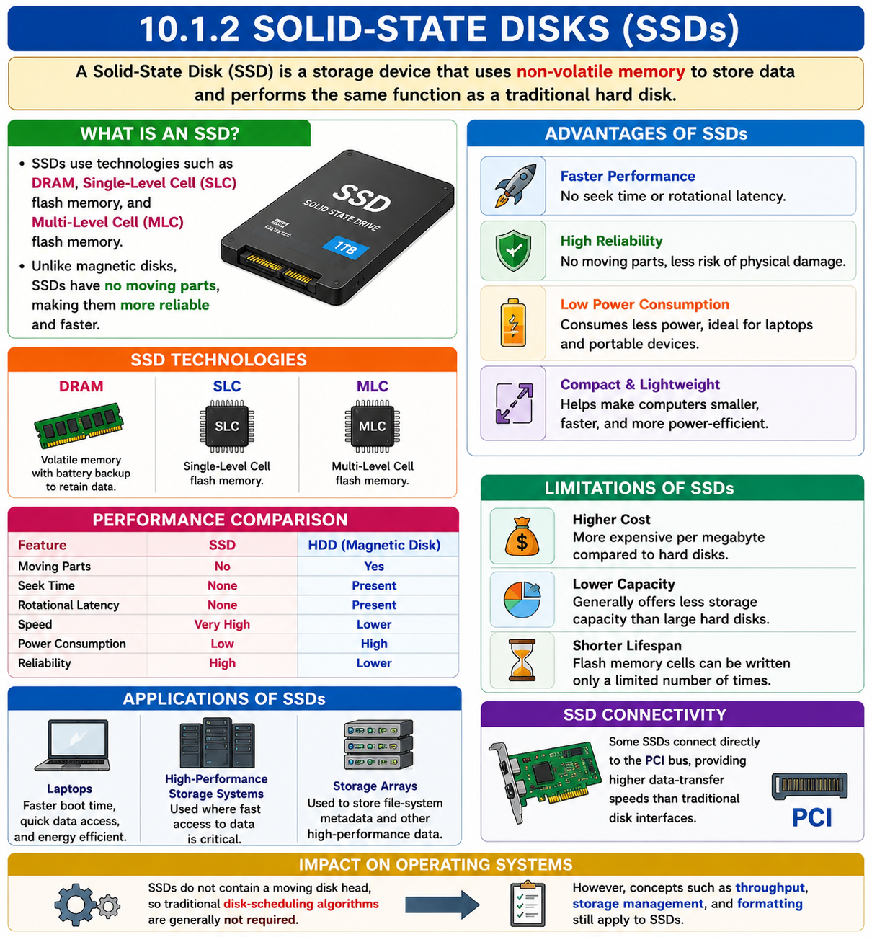

10.1.3 Magnetic Tapes

Introduction
Magnetic tape was one of the earliest forms of secondary storage. It is a relatively permanent storage medium capable of storing large amounts of data. However, its access time is much slower than that of main memory and magnetic disks.

Access Characteristics
Magnetic tapes provide sequential access, meaning data must be read in order. As a result, random access on magnetic tape is about 1,000 times slower than on a magnetic disk. Therefore, tapes are generally unsuitable for regular secondary-storage operations that require frequent data access.

Applications of Magnetic Tapes
Today, magnetic tapes are primarily used for data backup, archival storage, and transferring data between systems. They are ideal for storing information that is accessed infrequently but must be retained for long periods.

Working of Magnetic Tape
A magnetic tape is stored on a spool and moves past a read–write head during read and write operations. Locating a particular data item may take several minutes because the tape must be wound or rewound to the required position. Once the correct position is reached, data can be transferred at speeds comparable to those of disk drives.

Storage Capacity
Modern magnetic tapes can store several terabytes of data. Some tape technologies include built-in compression, which can more than double the effective storage capacity.

Tape Classification
Tape drives are commonly classified according to their width, such as 4 mm, 8 mm, 19 mm, 1/4 inch, and 1/2 inch. They may also be categorized by technology names such as LTO-5 (Linear Tape-Open 5) and SDLT (Super Digital Linear Tape).

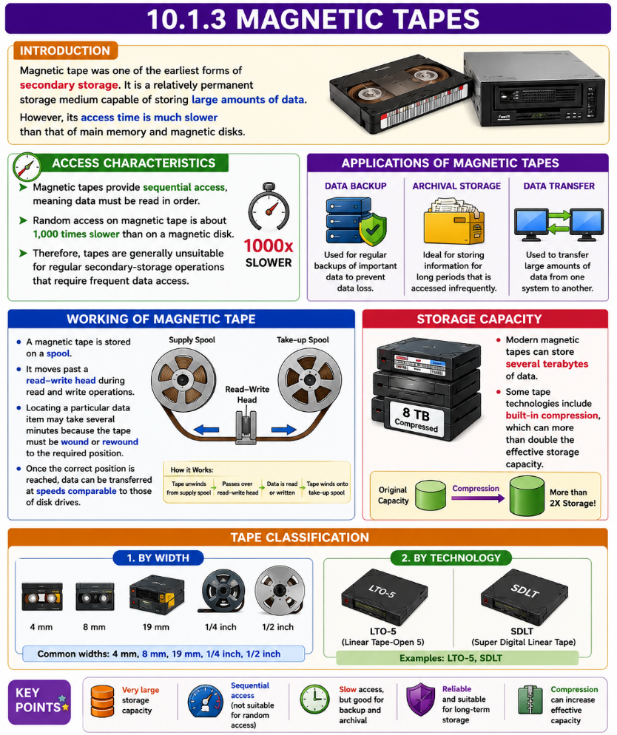

10.2 Disk Structure

Logical Block Addressing (LBA)
Modern magnetic disks are organized as a large one-dimensional array of logical blocks. A logical block is the smallest unit of data transfer and is typically 512 bytes, although some disks may use larger block sizes such as 1,024 bytes. The operating system accesses data using logical block numbers rather than physical disk locations.

Mapping of Logical Blocks
Logical blocks are mapped sequentially onto the disk sectors. Sector 0 is located on the first track of the outermost cylinder. The mapping continues through all sectors of a track, then through all tracks in the cylinder, and finally through all cylinders from the outermost to the innermost part of the disk.

Physical Disk Address
In theory, a logical block number can be converted into a physical disk address consisting of:
- Cylinder Number
- Track Number
- Sector Number
However, this conversion is difficult in practice because modern disks hide many physical details from the operating system.

Reasons for Translation Difficulty
The first reason is the presence of defective sectors. Disk manufacturers replace bad sectors with spare sectors, making the actual physical location different from the logical location. This process is hidden from the user and operating system.
The second reason is that the number of sectors per track is not always constant. Different tracks may contain different numbers of sectors depending on the disk technology used.

Constant Linear Velocity (CLV)
In Constant Linear Velocity (CLV) technology, the density of bits on each track remains uniform. Since outer tracks are longer than inner tracks, they can store more sectors. As a result, outer tracks may contain about 40% more sectors than inner tracks. To maintain a constant data rate, the disk increases its rotation speed when moving from outer tracks to inner tracks. This method is commonly used in CD-ROMs and DVD-ROMs.

Constant Angular Velocity (CAV)
In Constant Angular Velocity (CAV) technology, the disk rotates at a constant speed. To maintain a constant data transfer rate, the bit density decreases from inner tracks to outer tracks. This approach is commonly used in hard disk drives (HDDs).

Advances in Disk Technology
As disk technology improves, the number of sectors per track continues to increase. Modern disks may have several hundred sectors per track, especially in the outer zones, resulting in higher storage capacities and improved performance.
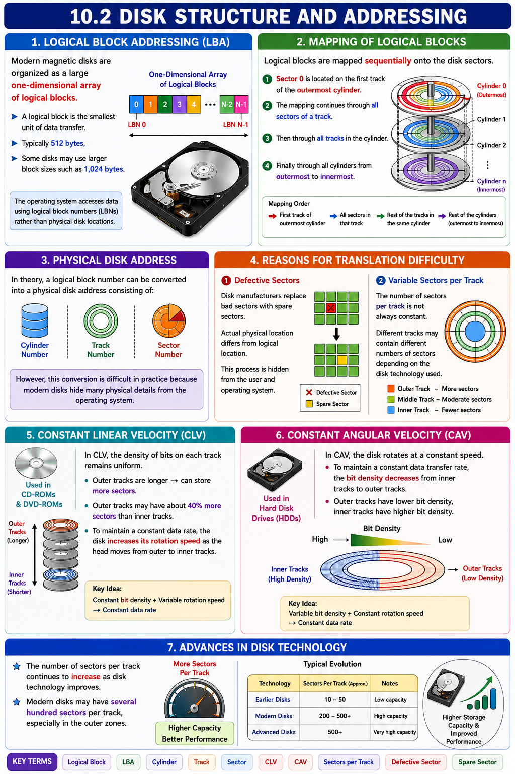

10.3 Disk Attachment

Computers access disk storage in two ways. One way is via I/O ports (or host-attached storage); this is common on small systems. The other way is via a remotehost inadistributedfile system; this is referredtoas network-attached storage.

Section Number | Title | Topics Studied
10.3 | Disk Attachment | Methods of connecting storage devices to computer systems, storage architectures, storage sharing, performance considerations, and communication between hosts and storage devices.
10.3.1 | Host-Attached Storage (HAS) | Directly attached storage devices, SATA, ATA, SCSI, SAS, USB interfaces, local storage access, disk controllers, advantages and limitations of host-based storage.
10.3.2 | Network-Attached Storage (NAS) | File-level storage over a network, dedicated file servers, shared storage access, NFS and SMB/CIFS protocols, centralized file management, NAS architecture, advantages and limitations.
10.3.3 | Storage-Area Network (SAN) | High-speed dedicated storage networks, block-level storage access, Fibre Channel (FC), iSCSI protocols, storage virtualization, enterprise storage management, scalability, performance benefits, and SAN architecture.

10.3.1 Host-Attached Storage
Host-Attached Storage (HAS) refers to storage devices that are connected directly to a computer through local I/O ports. The computer accesses the storage without using a network, providing fast and direct data access.
Desktop computers commonly use IDE (Integrated Drive Electronics) or ATA (Advanced Technology Attachment) bus architectures. These interfaces typically support up to two drives per I/O bus. A newer technology called SATA (Serial ATA) offers higher performance and simpler cabling than traditional ATA.
High-performance workstations and servers often use Fibre Channel (FC), a high-speed serial communication technology that operates over optical fiber or copper cables. Fibre Channel provides faster data transfer and supports connecting multiple storage devices and hosts.
Fibre Channel has two major variants. The first is a Switched Fabric, which uses a 24-bit address space and allows many hosts and storage devices to communicate efficiently. This technology forms the basis of Storage-Area Networks (SANs). The second variant is Fibre Channel Arbitrated Loop (FC-AL), which can connect up to 126 devices, including disk drives and controllers.
Various storage devices can be used as host-attached storage, including Hard Disk Drives (HDDs), RAID arrays, CD drives, DVD drives, and Tape drives. Data transfers are performed using read and write commands on logical data blocks directed to specific storage devices.
Host-Attached Storage (HAS), IDE, ATA, SATA, Fibre Channel (FC), Switched Fabric, FC-AL, RAID Array, Logical Block, Read Operation, Write Operation

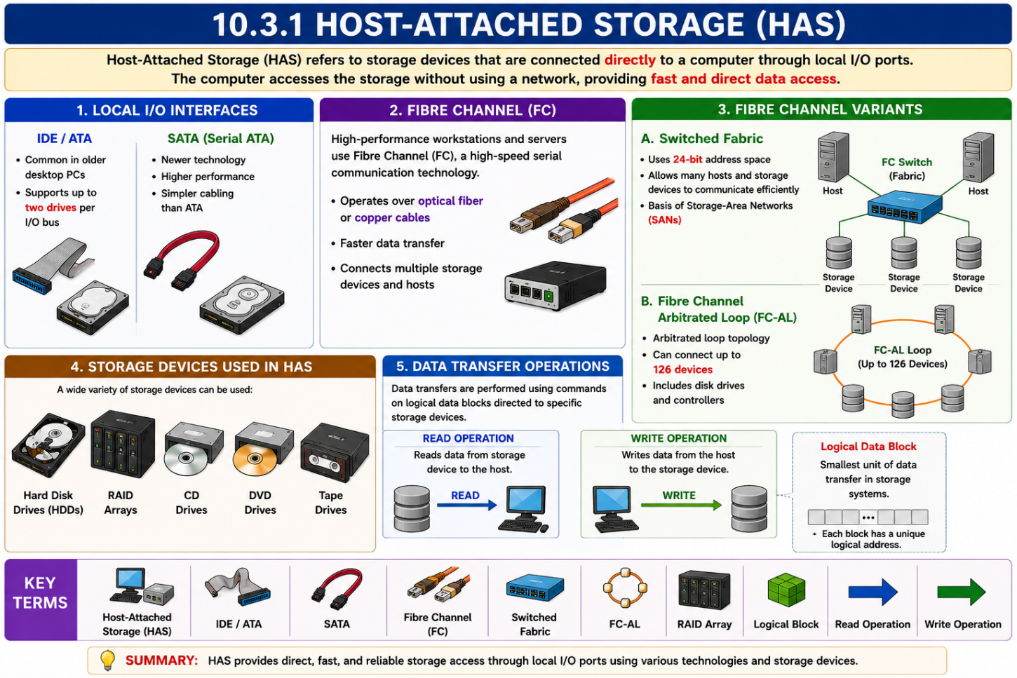

10.3.2 Network-Attached Storage
Network-Attached Storage (NAS) is a special-purpose storage system that is accessed remotely over a data network. Instead of being directly connected to a computer, the storage device is connected to the network, allowing multiple users and systems to access shared data.
Clients access NAS using remote procedure call (RPC) interfaces such as NFS (Network File System) in UNIX/Linux systems and CIFS (Common Internet File System) in Windows systems. These RPC requests are transmitted using TCP or UDP over an IP network, typically the same LAN (Local Area Network) used for normal network communication.
A NAS device is usually implemented using a RAID array along with software that provides the RPC interface. This combination offers centralized storage, improved reliability, and easier data management.
NAS enables all computers connected to a LAN or WAN to share a common storage pool with the same convenience as local storage. Users can access files using familiar file names and directory structures, making storage sharing simple and efficient.
However, NAS generally provides lower performance and less efficiency than direct Host-Attached Storage (HAS) because all storage requests must travel through the network.
A modern NAS technology is iSCSI (Internet Small Computer System Interface). iSCSI carries the SCSI protocol over IP networks, allowing network connections to replace traditional SCSI cables. As a result, hosts can access remote storage and use it as if it were directly attached to the system.
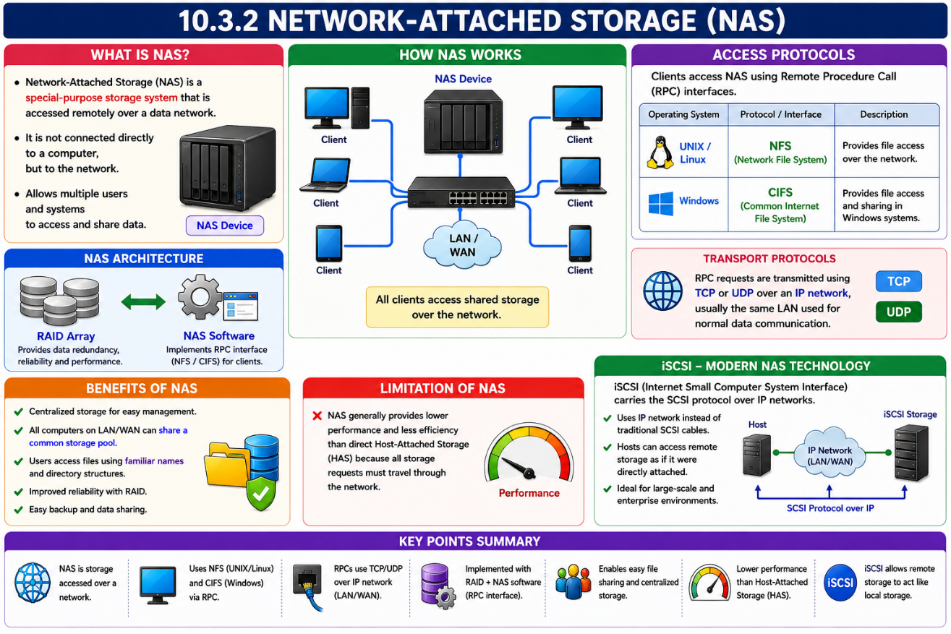

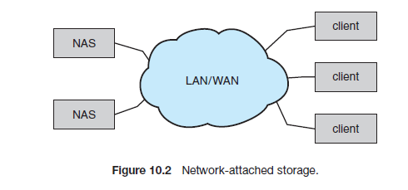

10.4 Disk Scheduling
One of the main responsibilities of the Operating System (OS) is to use disk hardware efficiently. To achieve this, the OS aims to reduce disk access time and increase disk bandwidth.
For magnetic disks, access time consists of two components: seek time, which is the time taken to move the disk arm to the required cylinder, and rotational latency, which is the time taken for the desired sector to rotate under the disk head.
Disk bandwidth is the total amount of data transferred divided by the total time taken to complete the transfer. The operating system improves access time and bandwidth by deciding the order in which disk requests are serviced, a process known as disk scheduling.
Whenever a process requires disk I/O, it sends a request to the operating system specifying the operation type (read/write), disk address, memory address, and number of sectors to be transferred. These requests are then scheduled efficiently to improve overall system performance.

Algorithm | Full Form | Definition / Working | Visual Definition (Image Idea) | Easy Memory Tip | Head Movement Strategy
FCFS | First-Come First-Served | Requests are serviced in the exact order they arrive in the queue. | People standing in a queue at a ticket counter. First person is served first. | "First Arrived, First Served" | No optimization; follows queue order.
SSTF | Shortest Seek Time First | The request nearest to the current head position is serviced first. | Person choosing the nearest shop instead of the farthest one. | "Nearest Neighbor First" | Jump to the closest pending request.
SCAN | Elevator Algorithm | Head moves in one direction servicing requests, reaches the disk end, then reverses direction. | Elevator going to the top floor and then coming back down. | "Go to Wall and Come Back" | Services requests while moving both ways.
LOOK | LOOK Algorithm | Similar to SCAN, but reverses direction at the last request instead of the disk end. | Elevator turning around at the highest floor where a passenger is waiting. | "Look Before Going Further" | Stops at last request and reverses.
C-SCAN | Circular SCAN | Head moves in one direction only. After reaching the disk end, it jumps back to the beginning. | Circular bus route: reaches last stop and returns directly to first stop. | "One-Way Circular Bus" | Services requests in only one direction.
C-LOOK | Circular LOOK | Similar to C-SCAN, but jumps from the last request directly to the first request without going to the disk end. | Circular bus that skips empty stops and jumps directly to the first passenger stop. | "Smart Circular Bus" | Circular movement only between first and last requests.

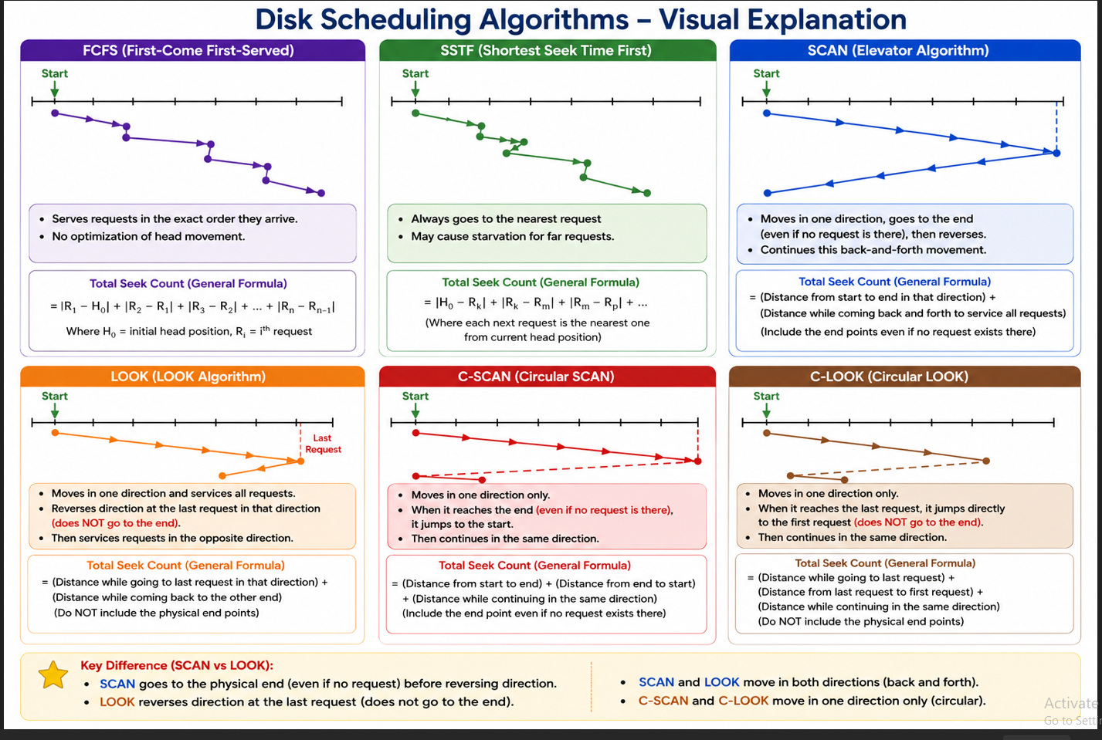

10.4.1 FCFS Scheduling
First Example
The simplest form of disk scheduling is, of course, the first-come, first-served (FCFS) algorithm. This algorithm is intrinsically fair, but it generally does not provide the fastest service. Consider, for example, a disk queue with requests for I/O to blocks on cylinders
98, 183, 37, 122, 14, 124, 65, 67,
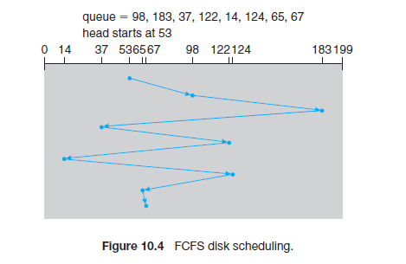
If the disk head is initially at cylinder 53, it will first move from 53 to 98, then to 183, 37, 122, 14, 124, 65, and finally to 67, for a total head movement of 640 cylinders. This schedule is diagrammed in Figure 10.4. The wild swing from 122 to 14 and then back to 124 illustrates the problem with this schedule. If the requests for cylinders 37 and 14 could be serviced
together, before or after the requests for 122 and 124, the total head movement could be decreased substantially, and performance could be thereby improved.

Second Example

Input:
Request sequence = {176, 79, 34, 60, 92, 11, 41, 114}
Initial head position = 50

Output:
Total number of seek operations = 510
Seek Sequence is
176
79
34
60
92
11
41
114

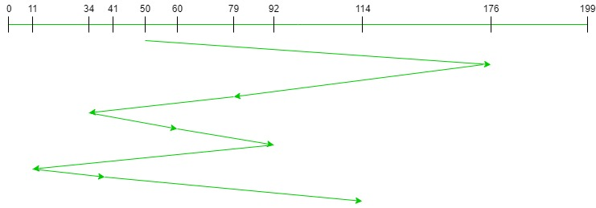
Therefore, the total seek count is calculated as
= (176-50)+(176-79)+(79-34)+(60-34)+(92-60)+(92-11)+(41-11)+(114-41)
= 510

Third Example

Consider the following disk requests arriving in the order: 98, 183, 37, 122, 14, 124, 65, 67. The image below shows how the disk head moves for the above request sequence using FCFS disk scheduling algorithm –
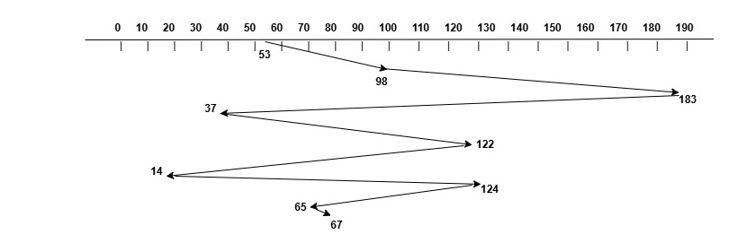
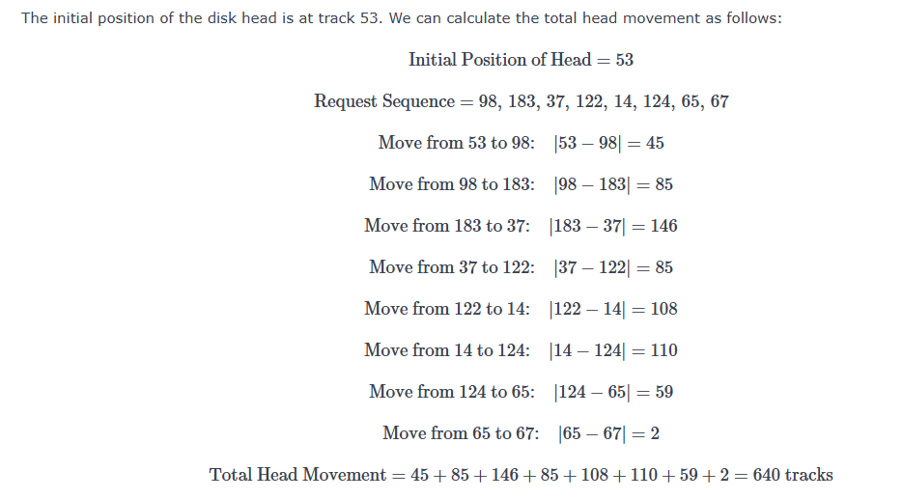

Fourth Example

Given a request sequence at tracks 82, 170, 43, 140, 24, 16, and 190, and the read/write head starts at 50, FCFS processes them in order of arrival.
Total Head Movement: (82–50) + (170–82) + (170–43) + (140–43) + (140–24) + (24–16) + (190–16) = 642 units.

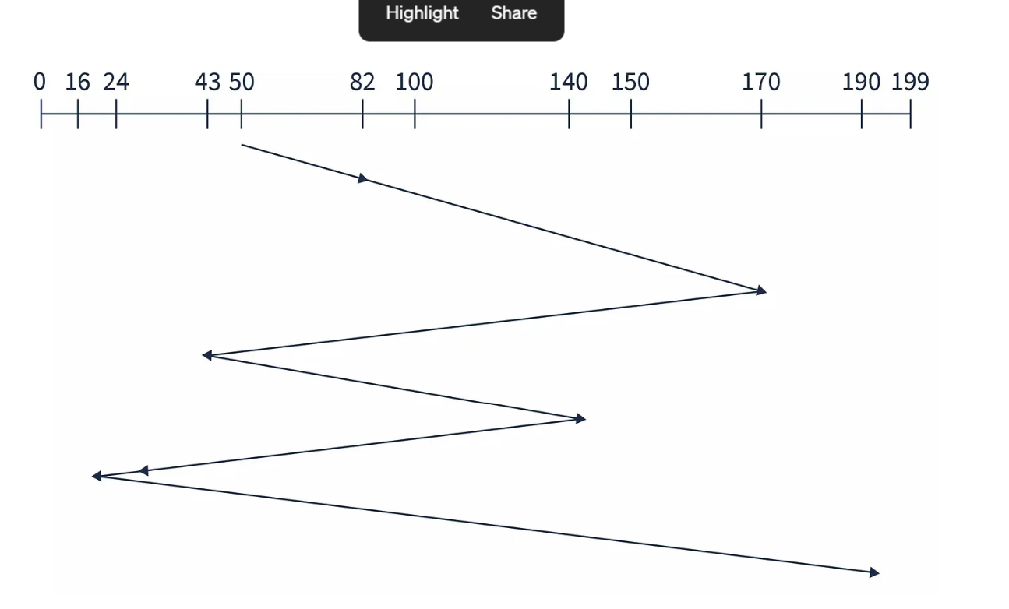

10.4.2 SSTF Scheduling
It seems reasonable to service all the requests close to the current head position before moving the head far away to service other requests. This assumption is the basis for the shortest-seek-time-first (SSTF) algorithm. The SSTF algorithm selects the request with the least seek time from the current head position. In other words, SSTF chooses the pending request closest to the current head position.
First Example
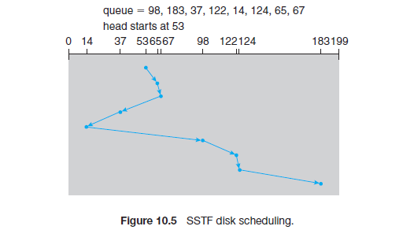
Consider a disk queue with requests for I/O to blocks on cylinders 98, 183, 41, 122, 14, 124, 65, 67. The SSTF scheduling algorithm is used

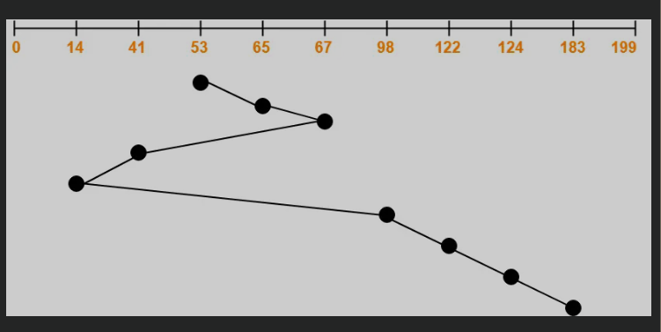

Total head movements incurred while servicing these requests
= (65 – 53) + (67 – 65) + (67 – 41) + (41 – 14) + (98 – 14) + (122 – 98) + (124 – 122) + (183 – 124)

= 12 + 2 + 26 + 27 + 84 + 24 + 2 + 59
= 236

Second Example

Using the same request sequence as above (82, 170, 43, 140, 24, 16, 190) with the head starting at 50, SSTF would process requests in the following order: 43 → 24 → 16 → 82 → 140 → 170 → 190.
Total Head Movement: (50–43) + (43–24) + (24–16) + (82–16) + (140–82) + (170–140) + (190–170) = 208 units.

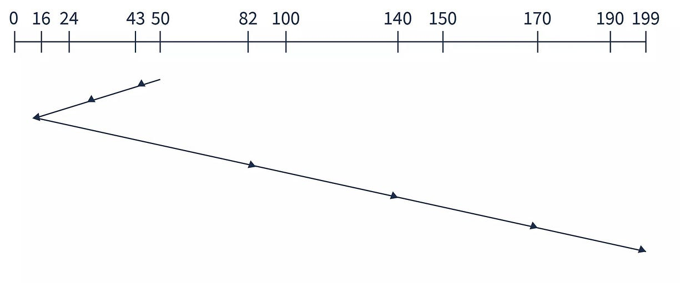

10.4.3 SCAN Scheduling
In the SCAN algorithm, the disk arm starts at one end of the disk and moves toward the other end, servicing requests as it reaches each cylinder, until it gets to the other end of the disk. At the other end, the direction of head movement is reversed, and servicing continues. The head continuously scans back and forth across the disk. The SCAN algorithm is sometimes called the elevator algorithm, since the disk armbehaves just like an elevator in a building, first servicing all the requests going up and then reversing to service requests the other way.
The SCAN algorithm is a disk scheduling method where the disk arm moves in one direction, servicing requests along the way, and then reverses direction at the end, similar to an elevator. It provides better performance than simple algorithms but may cause longer waiting time for some requests.
- Disk arm moves in one direction servicing requests
- Reverses direction after reaching the end
- Also known as the elevator algorithm
- Mid-range requests are served faster, others may wait longer

First Example
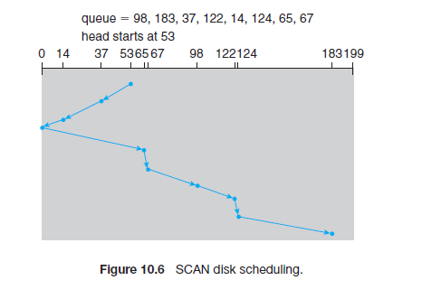
Second Example

Consider a disk queue with requests for I/O to blocks on cylinders 98, 183, 41, 122, 14, 124, 65, 67. The SCAN scheduling algorithm is used

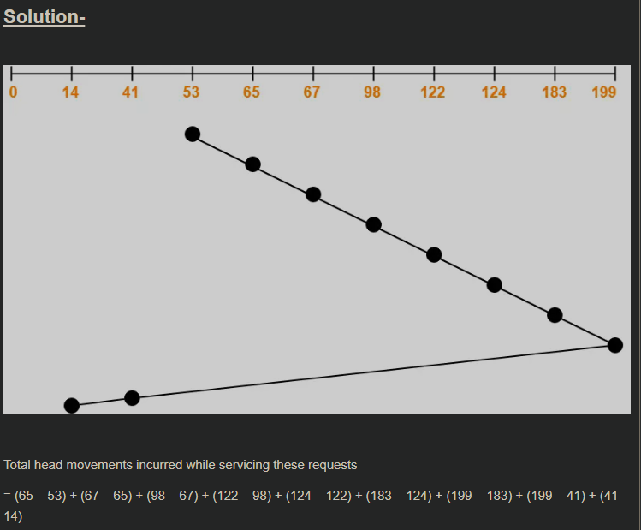

= 12 + 2 + 31 + 24 + 2 + 59 + 16 + 158 + 27
= 331

Alternatively,
Total head movements incurred while servicing these requests
= (199 – 53) + (199 – 14)
= 146 + 185
= 331

Third Example
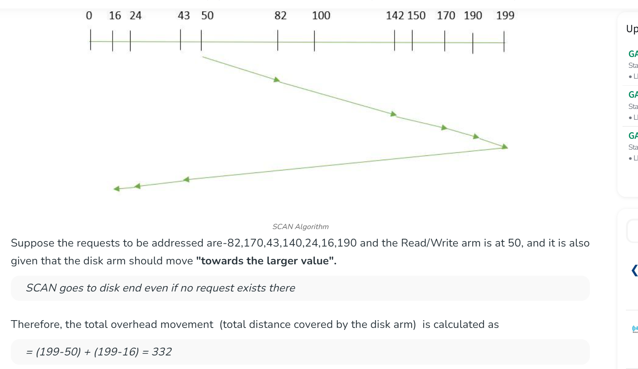

Fourth Example

Consider a disk with 200 tracks (0-199) and the disk queue having I/O requests in the following order as follows: 93, 176, 42, 148, 21, 14, 180. The current head position of the Read\Write head is 55. Calculate the total number of track movements of Read/Write head using SCAN.

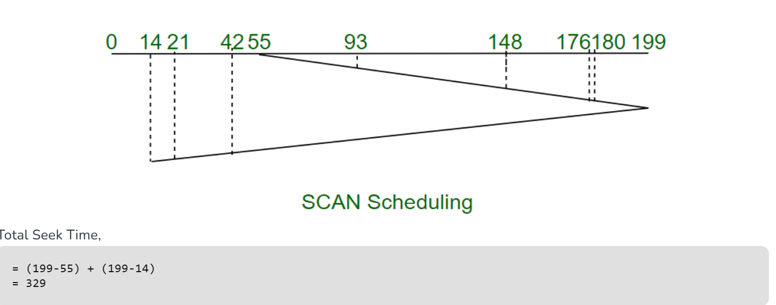

Fifth Example

A disk has 251 tracks and a queue of access requests: 240, 94, 179, 51, 118, 15, 137, 29, and 75. The Read/Write head (C) is initially located at track 55 and is moving to the right:

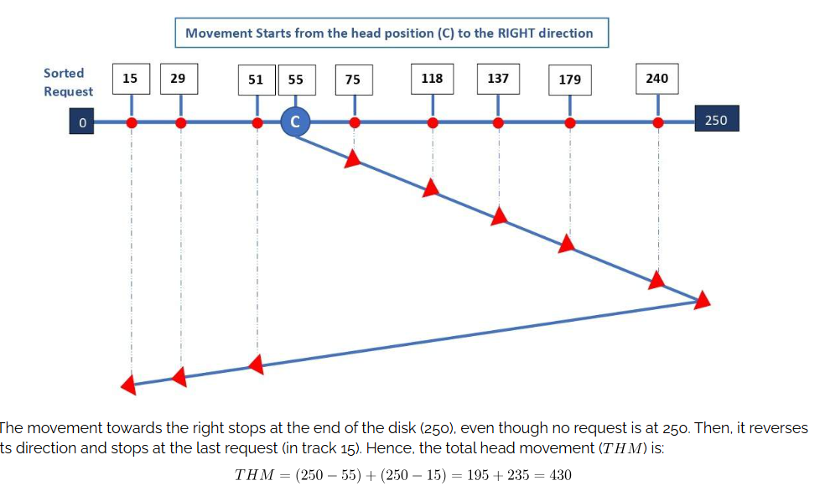

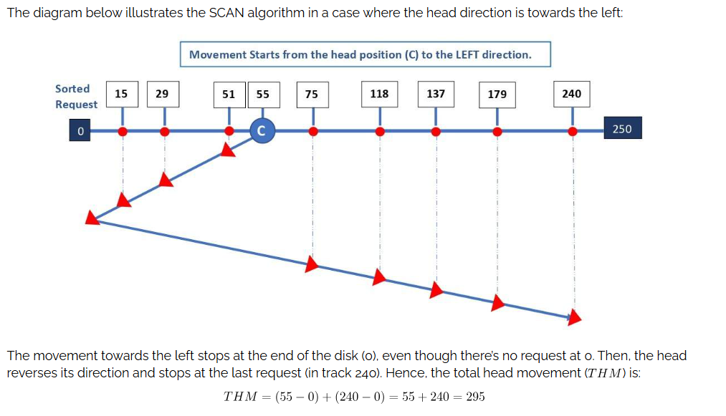

Sixth Example

Assuming the head starts at 53 and starts moving towards left end

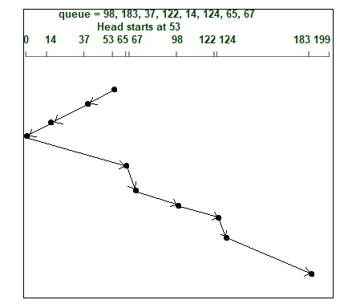
(53−37)+(37−14)+(14−0)+(65−0)+(67−65)+(98−67)+(122−98)+(124−122)+(183−124)
16+23+14+65+2+31+24+2+59=236

10.4.4 C-SCAN Scheduling
Circular SCAN (C-SCAN) scheduling is a variant of SCAN designed to provide a more uniform wait time. Like SCAN, C-SCAN moves the head from one end of the disk to the other, servicing requests along the way. When the head reaches the other end, however, it immediately returns to the beginning of the disk without servicing any requests on the return trip (Figure 10.7). The
C-SCAN scheduling algorithm essentially treats the cylinders as a circular list that wraps around from the final cylinder to the first one.
C-SCAN (Circular SCAN) is an improvement over the SCAN algorithm where the disk arm moves in one direction only. Instead of reversing, it jumps back to the beginning of the disk and continues servicing requests, providing more uniform wait times.
- Disk arm moves in one direction only
- After reaching the end, it jumps to the beginning
- Services requests in a circular manner
- Provides more uniform waiting time compared to SCAN

First Example
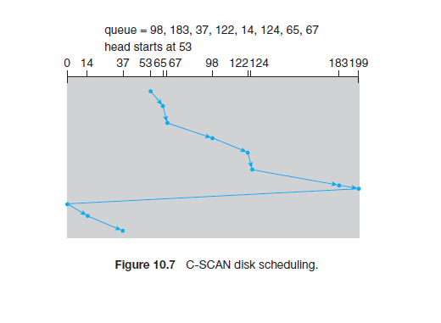
Second Example
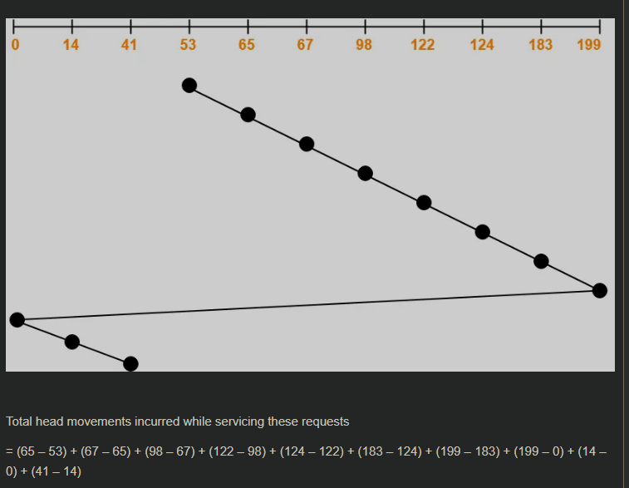

= 12 + 2 + 31 + 24 + 2 + 59 + 16 + 199 + 14 + 27

= 386

Alternatively,

Total head movements incurred while servicing these requests

= (199 – 53) + (199 – 0) + (41 – 0)

= 146 + 199 + 41

= 386

Third Example
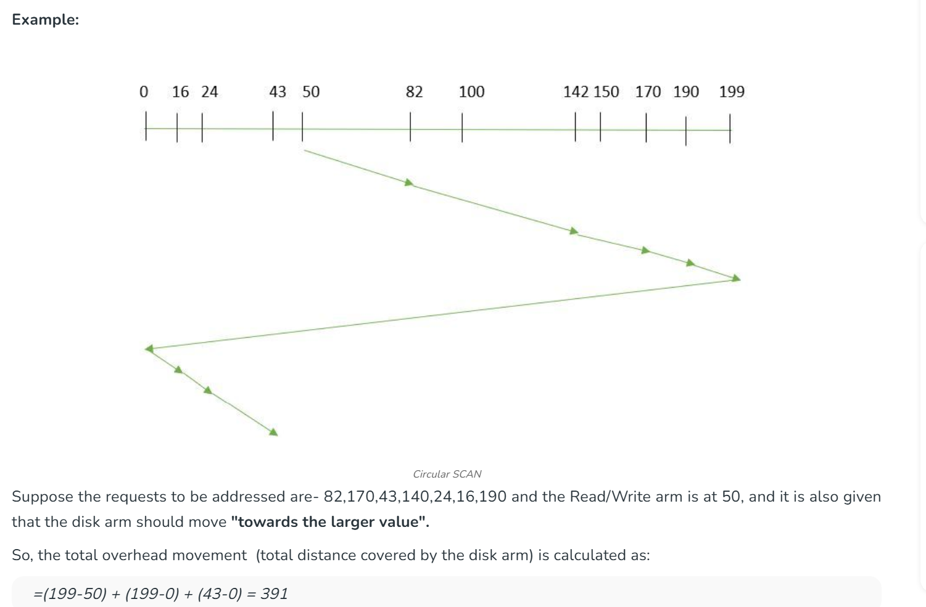

Fourth Example
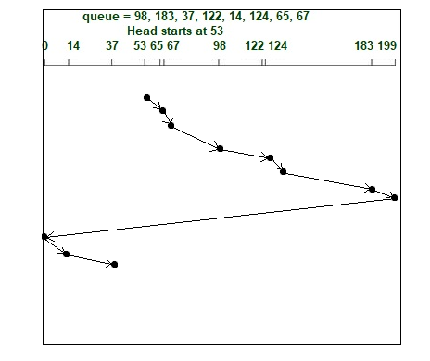
(65−53)+(67−65)+(98−67)+(122−98)+(124−122)+(183−124)+(199−183)+(199−0)+(14−0)+(37−14)
12+2+31+24+2+59+16+199+14+23=382

10.4.5 LOOK Scheduling
As we described them, both SCAN and C-SCAN move the disk arm across the full width of the disk. In practice, neither algorithm is often implemented this way. More commonly, the arm goes only as far as the final request in each direction. Then, it reverses direction immediately, without going all the way to the end of the disk. Versions of SCAN and C-SCAN that follow this pattern are called LOOK and C-LOOK scheduling, because they look for a request before continuing to move in a given direction (Figure 10.8)

LOOK is a disk scheduling algorithm similar to SCAN, but instead of moving the disk arm to the end, it only goes up to the last pending request in that direction and then reverses, reducing unnecessary movement.
- Moves disk arm only up to the last request, not the disk end
- Reverses direction after servicing the last request
- Avoids unnecessary disk traversal
- Improves efficiency and reduces seek time compared to SCAN
First Example
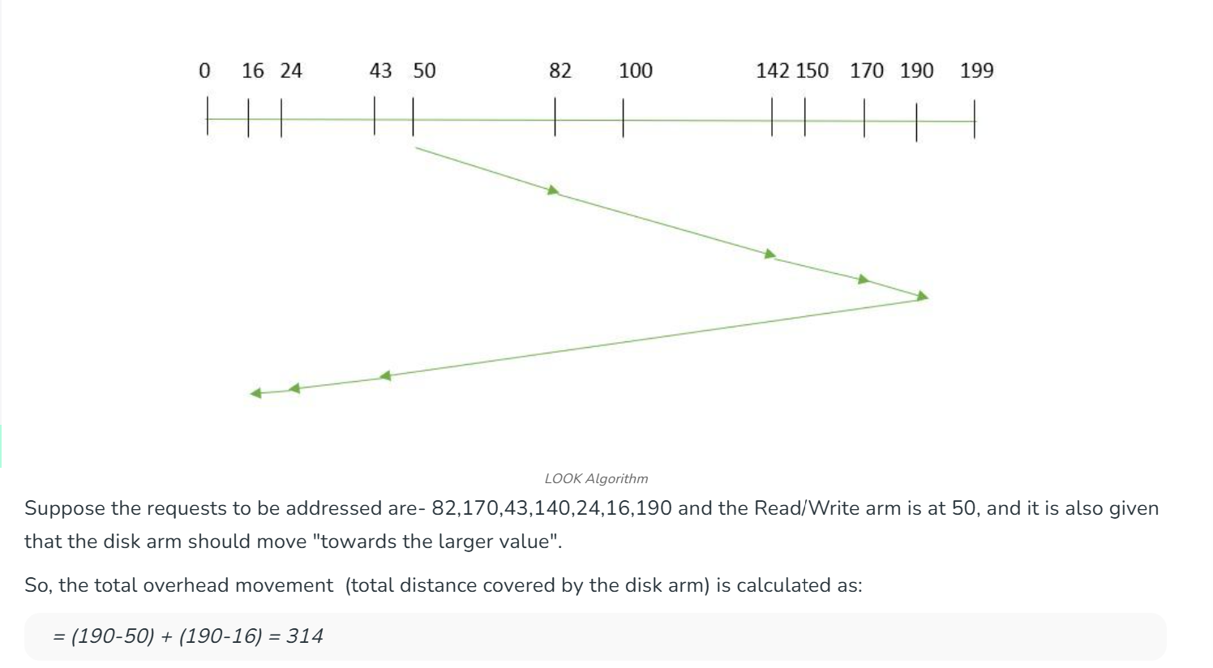

Second Example

Let’s consider an example of a disk with 251 tracks and a queue of disk access requests in the following order: 240, 94, 179, 51, 118, 15, 137,29 75. The current position of the Read/Write head (C) is at track 55 and moving in the Right direction. The LOOK algorithm can be illustrated as shown in the below diagram:

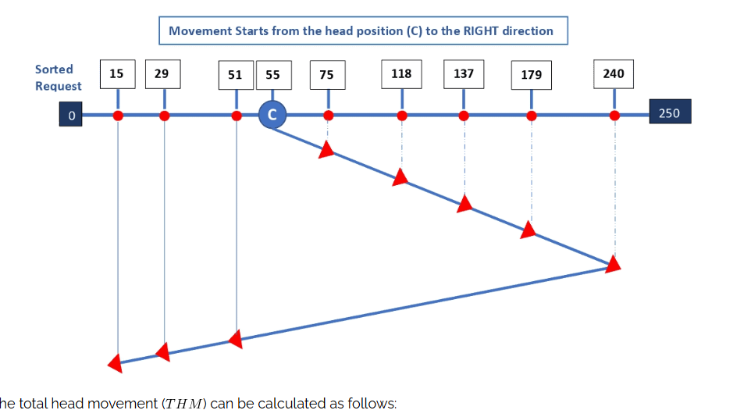

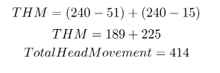

10.4.6 c-LOOK Scheduling

C-LOOK is similar to C-SCAN but avoids unnecessary movement by going only up to the last request in one direction and then jumping to the last request at the other end, instead of going to the disk’s extreme end.
- Moves only up to the last request in one direction
- Jumps to the last request at the other end
- Does not go to the physical disk end
- Reduces unnecessary movement and improves efficiency

First Example
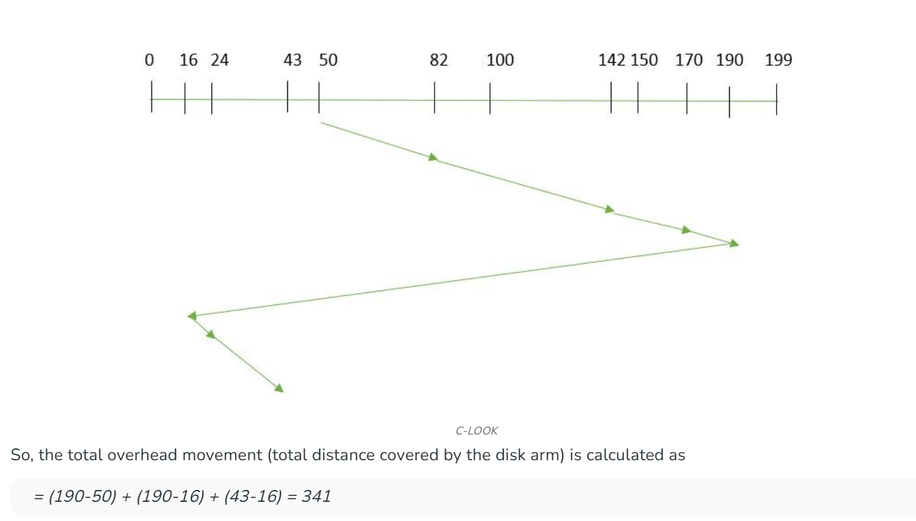

Second Example

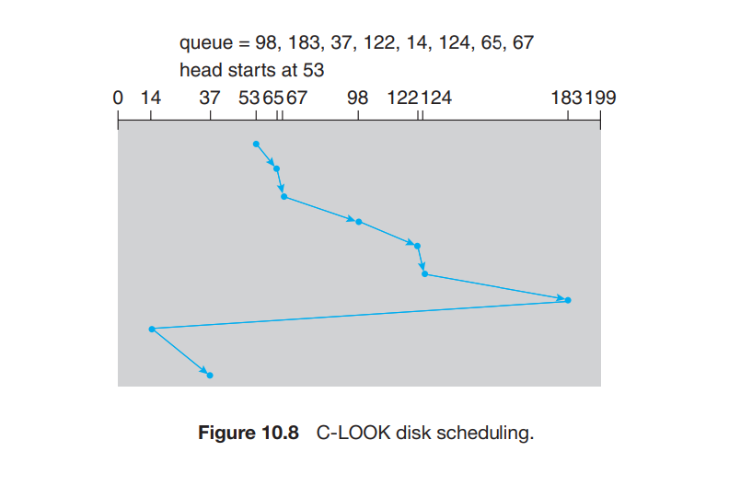

Third Example
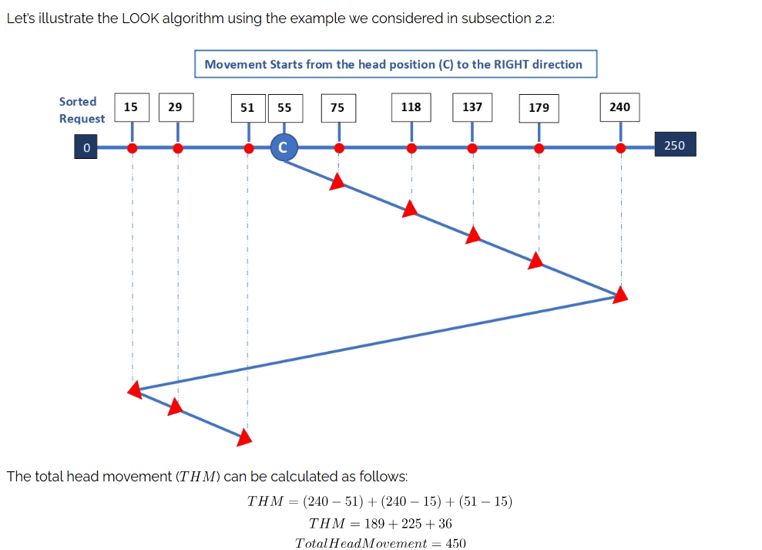

Exam Type Questions

On a disk with 1000 cylinders, number 0 to 999, compute the number of tracks the disk arm must move to satisfy all the requests in the disk queue. Assume the last request serviced was at track 345 and the head is moving toward track 0. The queue in FIFO order contains requests for the following tracks,
123, 874, 692, 475, 105, 376.
